Dataprocessing design workshop 2

Thom Mekelenkamp

Design critique

What is the problem domain or context of the visualization under consideration?

• Which tasks can be achieved with this visualization?

* You can see the worldwide gross from more than 600 movies
* See the ratings by audience and critics, and compared to each other
* You can see the budget of the movies
* By clicking on the numbers you can see a summary of the movie and the cast

• Tufte’s principles of graphical integrity:

* There is only one scale, which is labeled from 0 to 80+. This represents the score highest score that the movie got from either the audience of from the critics.
* The lie factor in the graph is pretty low. Because the only scale in the graph has a linear growth, which means in case of this movies that there will be an accurate representation of the scores.
* The visualization does show data variation. The variation is between the rating from the audience and the critics. Each one gets their own bulb the one of the critics is purple and the one of the audience is pink. This makes the visualization very crowded and very messy.

• Tufte’s visualization design principles, are they adhered to?

* The data-ink ratio is fairly high because all the data is stuffed into one graph. The data-ink could have been higher up if the bulbs were combined in one bulb with additional info when clicked on.
* I think that there is a lot of chart junk. I think that there shouldn’t be separate bulbs for the audience and from the critics. But combined in one bulb, or in separate tabs. At this moment there is just too much in the visualization that isn’t really interesting.
* The data density of this visualization is high. When you take a look at it you’ll see the whole graph filled up with pink and purple bulbs. All the bulbs are partly transparent which makes it more crowded.
* The layer information in this visualization is when you click on one of the bulbs. Then a new layer opens up in the foreground. This layer shows additional information about the movie.

• Graphic design principles:

* The contrast that is used in this visualization is very low. The two colors that make up the graph do look very much like each other. Complimentary Contrast is used in this visualization.
* Repetition is used once for the two types of bulbs. The rest of the visualization consists of unique forms.
* The alignment in the visualization is the only scale. The bulbs are aligned to this scale in order of highest rating.
* In this graph is everything close onto each other. a lot of bulbs are touching each other and you could say that there wasn’t really much attention paid to the proximity of the bulbs from one to another.

• Comment on the visual encodings that are used.

* There is just only one visual encoding. Which is the bulb/circle.
* Yes, the encodings are appropriate for the information that they are used for.

• Comment on subjective dimensions such as aesthetics, style, playfulness

and vividness.

* Personally I think that the graph on first glance is a big mess of bulbs. The combination of two different pieces of information in 1 shape with colors that look very identical is far from an ideal representation.

• What is the intended goal of the visualization and is that goal achieved?

* The goal Is to inform me over budget and profit of a movie, compare that to the scores that they get from audience and critics. This goal is definitely reached but it took some time to figure out how the graph and representations work.

• Are there any things you would do differently, and why?

* Combine the two ratings from critics and the audience in one bulb. When hovered on the bulb you get the score of both parties just like there is now.

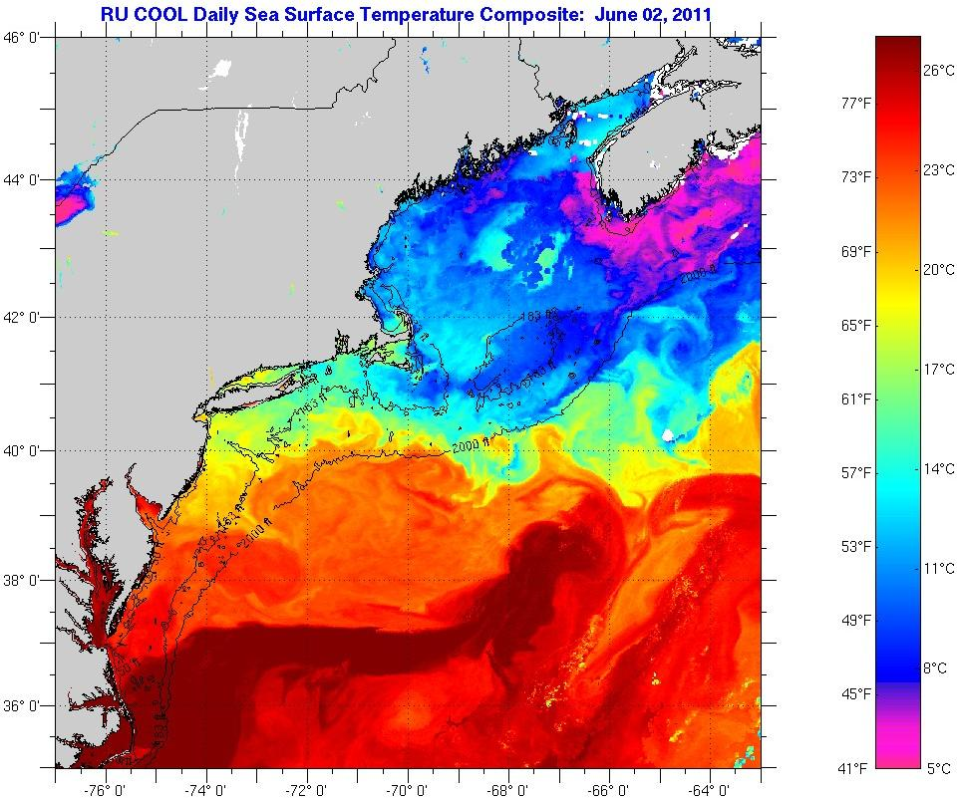Rainbow color map

The visualization represents the temperature data of the mid Atlantic Ocean surface on the 2nd of June 2011. The image is intended to be for meteorologists.

The visualization does very good at conveying the information that is it. The only thing that is less clear is the exact location of the image. Since the coastal lines on the image aren’t really clear it people can find it difficult to see where the exact location is.

The use of rainbow colors was very useful, the colors represent the temperatures of the surface. Since the colors flow into each other in the visualization it remains easy to distinguish different temperatures by there color.